Calculating Family Expenses using Service now Documentation format

- Introduction
Project Title: Calculating Family Expenses using Service now

Team Members:
P. Sruthi: Developer & Documentation
G. Praveen Kumar
C. Suchithra
T. Harshitha

Project Overview:
The Family Expense Management System is designed to help families track, manage, and analyze their daily expenses using the ServiceNow platform.
The system allows users to:
  - Add daily expenses (food, travel, bills, education, medical, etc.)
  - Categorize expenses
  - Calculate total monthly expenses
  - Compare income vs expenses
  - Generate reports and dashboards
This helps families control overspending, plan budgets, and save money.

Purpose:

- To maintain a centralized record of all family expenses
- To automatically calculate total daily, monthly, and yearly expenses
- To categorize spending for better financial planning
- To generate real-time reports and dashboards
- To reduce manual calculations and errors
- To help families make better financial decisions

Features:

- Expense entry form (date, category, amount, description)
- Income entry form
- Auto calculation of total expenses
- Balance calculation (Income – Expenses)

- Monthly expense report
- Category-wise spending chart
- ServiceNow dashboard with widgets
- User roles (Admin, Family Member)
- Secure data storage in ServiceNow tables

Architecture:

Frontend (ServiceNow Portal / Form UI)

- Users interact through ServiceNow forms
- They can add expenses and income using catalog items
- Data is submitted and stored in ServiceNow tables
- Dashboards display charts and totals User Actions:
- Enter expense details
- Select category
- Submit form
- View reports

Backend (ServiceNow Logic)

Backend is implemented using:

- Business Rules
- Script Includes
- Flow Designer / Workflows
- GlideRecord for calculations System Functions:
  - Store expense records

  - Calculate total expenses

  - Calculate total income

  - Compute remaining balance

  - Generate monthly summary

Setup Insructions:

Prerequisites

- ServiceNow Personal Developer Instance (PDI)
- Basic knowledge of tables and forms
- Roles: admin or developer

Installation / Configuration Steps

- Create a custom application → Family Expense Management

- Create tables:

Family Expense Table
  - Date
  - Category
  - Amount
  - Description
  - Entered by

Family Income Table
  - Date
  - Source
  - Amount
- Create forms for both tables

- Create Business Rule to calculate totals

- Create Script Include for expense calculation

- Create Dashboard for reports

- Folder Structure (ServiceNow Application Structure) :

Since this is built in ServiceNow, components are organized as:
Application: Family Expense Management

Contains:
- Tables – Expense, Income
- Forms – Expense Form, Income Form
- Business Rules – Total Calculation Rule
- Script Includes – ExpenseCalculator

- Reports – Monthly Expense Report
- Dashboard – Family Finance Dashboard

Running the Application Steps to Use:
- Login to ServiceNow instance
- Open Family Expense Application
- Click Add Expense
- Enter details and submit
- Click Add Income
- Open Dashboard to view:
  - Total Expenses
  - Total Income
  - Balance
  - Category-wise chart

API Documentation

Script Include: ExpenseCalculator
Purpose: Calculate total expenses and balance

Functions:
- getTotalExpenses() → Returns sum of all expense amounts
- getTotalIncome() → Returns sum of all income amounts
- getBalance() → Income – Expenses

Example Logic (concept):
  - Fetch all expense records using GlideRecord
  - Sum the amount field
  - Return total

Business Rule
Trigger: After Insert / Update on Expense tableAction:
- Recalculate total expenses
- Update dashboard values

Authentication

ServiceNow uses role-based access control (RBAC) Roles:

Admin:
- Create categories
- View all records
- Manage users

Family Member:
- Add expenses
- View reports
- Cannot delete others’ data

User Interface
The UI is built using:
- ServiceNow Forms for data entry
- Service Portal for user-friendly interface
- Dashboard widgets for visualization
Dashboard Widgets:
- Total Expense
- Total Income
- Remaining Balance
- Pie chart – Category-wise spending
- Bar chart – Monthly expenses

Testing

Testing Strategy:

- Manual testing of expense entry
- Verified calculations for totals
- Tested different categories
- Checked balance calculation
- Verified dashboard updates in real time
- Tested role-based access

Tools Used:

- ServiceNow PDI
- Test records
- Debug Business Rules

Screenshots / Demo

Formula used:
Total Expenses = Sum of all expense records Total Income = Sum of all income records Balance = Total Income – Total Expenses
Category-wise totals are calculated using filters in reports.
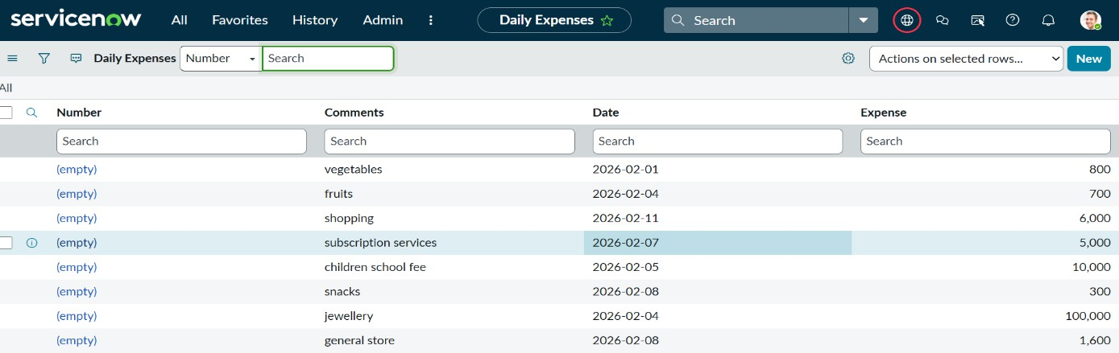

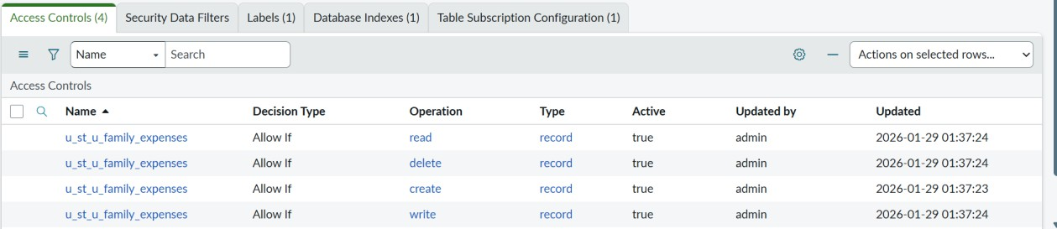

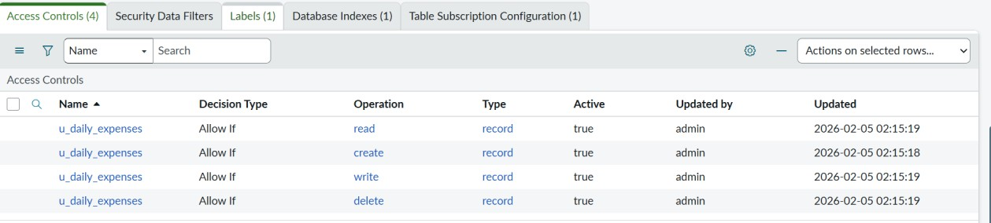

Demo Link:
https://drive.google.com/file/d/1DiMr6-XVSVD3Dce03oM93nY- xelo6lfo/view?usp=drive_link

Known Issues
- No mobile responsive portal (if not configured)
- Manual category creation required
- No notification when budget exceeds limit
- No multi-family support (single family data only)

Future Enhancements
- Budget limit alerts (email notification)
- Mobile app integration
- Multi-family account support
- AI-based expense prediction
- Auto bank statement import
- Monthly savings recommendation
- Voice-based expense entry

